National University of Computer & Emerging Sciences, Karachi
Spring -2026 FAST School of Computing
Assignment- 3 and Practice Questions for Final Exam
28th April, 2026
Course Code: EE1005 | Course Name: Digital Logic Design (DLD)
Instructor:
Date of Submission | 08 May, 2026

- a) If the waveforms in Fig-1 are applied to an active-Low S-R latch, draw the resulting Q output waveform in relation to the inputs. Assume that Q starts Low.
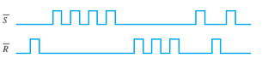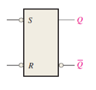
Fig-1

- Solve problem -1 for the input waveform in Fig-2 applied to an active –High S-R latch.

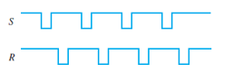
Fig-2

- Solve problem -1 for the input waveform in Fig-3.
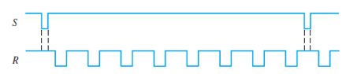
Fig-3

- For a gated S-R latch, determine the Q and Q’ output for the inputs in Fig-4. Show them in proper relation to the enabled input. Assume that A starts LOW. 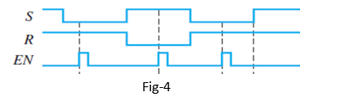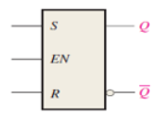

- Determine the output of the gated D latch for the inputs in Fig-5 and Fig-6.

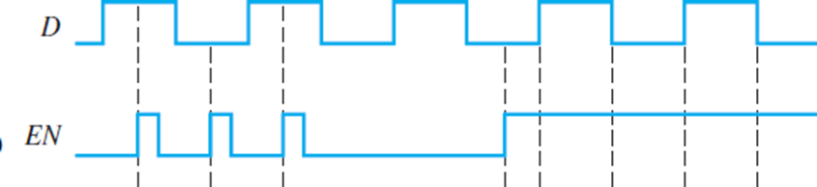
Fig-5

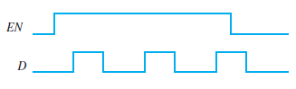
Fig-6

- The Q output of an edge-triggered D flip-flop is shown in relation to the clock signal in Fig-7. Determine the input waveform on the D input that is required to produce this output if the flip-flop is a positive edge-triggered type.
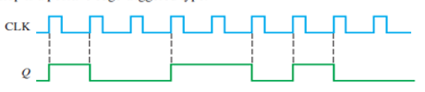
Fig-7

- a) Determine the Q waveforms relative to the clock if the signal shown in Fig -8 are applied to the input of the J-K flip-flop. Assume that Q initially LOW.
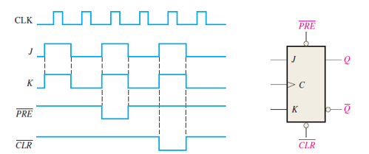
Fig-8

- For negative edge-triggered J-K flip-flop with the input in Fig-9, develop the Q output waveform relative to the clock. Assume that Q is initially LOW.
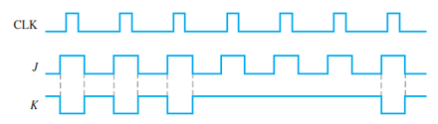
Fig-9

- For the circuit in Figure -10, complete the timing diagram in Fig-11 by showing the Q output (which is initially LOW). Assume PRE and CLR remain HIGH.
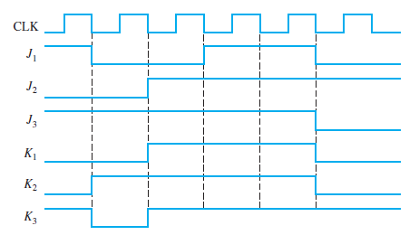
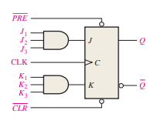

Fig-11 Fig-10

- A D flip-flop is connected as shown in Fig-12. Determine the Q output in relation to the clock. What specific function does this device perform?
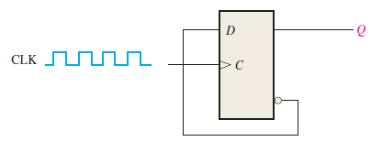
Fig-12

3 a) Design a MOD-6 synchronous counter using D flip-flops.
- Define the state sequence (0 to 5)
- Handle unused states properly
- Derive next-state equations
- Implement using logic gates + flip-flops
b) Design a 4-bit ripple (asynchronous) counter with:
- Enable (EN) control input
- Asynchronous reset to 0000
- Explain how propagation delay affects output transitions
- Identify potential glitches or timing issues

4 a) Design a synchronous counter that follows the sequence:

0 → 3 → 5 → 6 → 0
- Represent the sequence in binary form.
- Construct the state transition table.
- Design the counter using:
  - JK flip-flops (derive excitation equations)
  - D flip-flops (derive next-state equations)
- Draw the logic circuit diagrams for both implementations.
- Explain how invalid states (unused states) are handled to ensure proper operation.

b) Design a 3-bit synchronous up/down (forward/backward) counter using JK flip-flops.
Consider, a control input M determines the mode:
  - M=1 → Up counter (000 → 001 → ... → 111 → 000)
  - M=0 → Down counter (111 → 110 → ... → 000 → 111)
In this regard,
- Construct the state transition table for both modes.
- Derive the JK excitation equations for each flip-flop.
- Implement the design using minimum logic gates.
- Draw the complete circuit diagram.
- Briefly explain how the control input M affects the counting direction.

5. A system contains two 4-bit registers R1 and R2 and a control signal LOAD.
- Design a circuit such that:
- When LOAD = 1, the content of R1 is transferred to R2 on the next clock edge
- When LOAD = 0, R2 retains its previous value
- Draw the block diagram.
- Implement the design using D flip-flops and multiplexers.
- Write the input equation for each bit of R2.
- Explain the role of clock and control signal in synchronization.

